**DIWALI ASSIGNMENT**

**NAME: VANSHAJ RAGHUVANSHI**

**EMAIL: vanshajraghuvanshi@gmail.com**

**CLASS: 1CS12**

**APPLICATION NUMBER: 29128**

Que 1: **Write a C program to find whether the given number is odd or even, using Bitwise ' & ' Operator**

***CODING:-***

#include<stdio.h>

int main()

{

printf("NAME: VANSHAJ RAGHUVANSHI\nROLL/APP. NO.: 29128\n");

printf("PROGRAM TO CHECK IF A NUMBER IS EVEN OR ODD USING BITWISE &\n\n");

int n;

printf("Enter the number:\n");

scanf("%d",&n);

if((n&1)==1)

{

printf("Odd");

}

else

{

printf("Even");

}

return 0;

}

***OUTPUT:-***

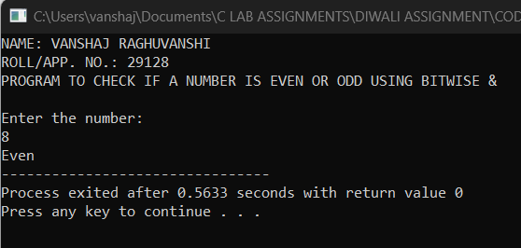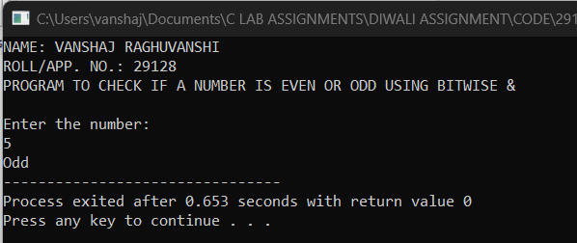

**Que 2:** **Splitting into Teams**

***CODING:-***

#include<stdio.h>

int main()

{

printf("NAME: VANSHAJ RAGHUVANSHI\nROLL/APP. NO.: 29128\n");

printf("PROGRAM TO DIVIDE STUDENTS INTO TEAMS\n\n");

int a,b;

printf("Number of sudents:\n");

scanf("%d",&a);

printf("Number of teams:\n");

scanf("%d",&b);

printf("The number of students in each team is %d and left out is %d",a/b,a%b);

return 0;

}

***OUTPUT:-***

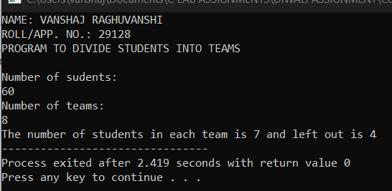

**Que 3: Change Position**

***CODING:-***

#include<stdio.h>

int main()

{

printf("NAME: VANSHAJ RAGHUVANSHI\nROLL/APP. NO.: 29128\n");

printf("PROGRAM TO CENTER A BED IN A SQUARE ROOM \n\n");

int x,y,a;

printf("Enter the x-coordinate of the left bottom vertex:\n");

scanf("%d",&x);

printf("Enter the y-coordinate of the left bottom vertex:\n");

scanf("%d",&y);

printf("Enter the length of a side:\n");

scanf("%d",&a);

int x1=x+(a/2);

int y1=y+(a/2);

printf("The centre of the room is at (%d,%d)",x1,y1);

return 0;

}

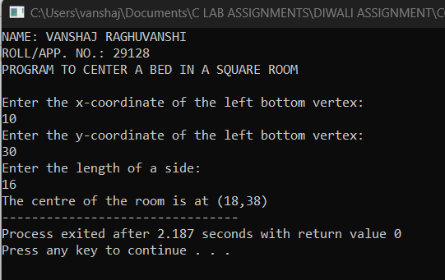***OUTPUT:-***

**Que 4: Calculating Gain Percentage**

***CODING:-***

#include<stdio.h>

int main()

{

printf("NAME: VANSHAJ RAGHUVANSHI\nROLL/APP. NO.: 29128\n");

printf("PROGRAM TO CALCULATE GAIN PERCENTAGE \n\n");

int a,b,c;

float p;

printf("Price of old scooter: ");

scanf("%d",&a);

printf("Repair amount: ");

scanf("%d",&b);

printf("Selling price: ");

scanf("%d",&c);

int n=c-a-b;

int d=a+b;

p=(float)n/d;

printf("Gain percentage is %.2f",p*100);

return 0;

}

***OUTPUT:-***

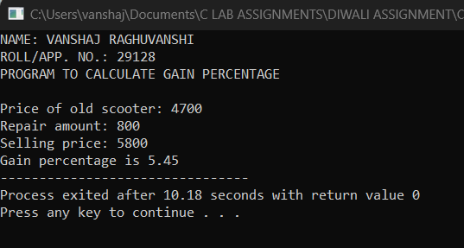

**Que 5: CAN I PLAY?**

***CODING:-***

#include<stdio.h>

int main()

{

printf("NAME: VANSHAJ RAGHUVANSHI\nROLL/APP. NO.: 29128\n");

printf("CAN I PLAY?\n\n");

int a;

printf("Age:");

scanf("%d",&a);

if(a>=0&&a<=100)

{

if(a>=0&&a<=3)

{

printf("TODDLER\n");

}

else if(a>=4&&a<=12)

{

printf("JUNIOR\n");

}

else if(a>=13&&a<18)

{

printf("TEENAGER\n");

}

}

else

{

printf("INVALID\n");

}

if(a>=0&&a<18)

{

printf("ALLOWED");

}

else

{

printf("NOT ALLOWED");

}

return 0;

}

***OUTPUT:-***

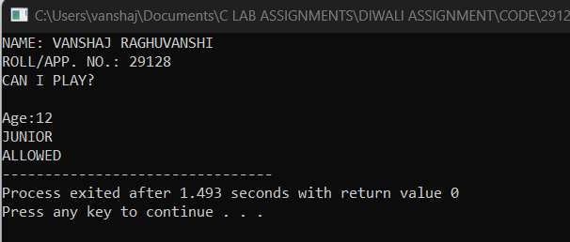

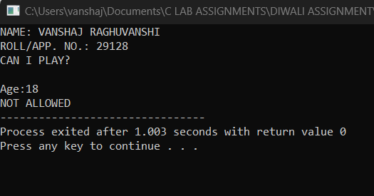

Que 6: KAPREKAR NUMBER

***CODING:-***

#include<stdio.h>

#include<math.h>

int main()

{

printf("NAME: VANSHAJ RAGHUVANSHI\nROLL/APP. NO.: 29128\n");

printf("PROGRAM TO CHECK IF ENTERED NUMBER IS KAPREKAR NUMBER\n\n");

int n;

printf("Enter the number: ");

scanf("%d",&n);

int i,sum,c,x,y,d;

x=pow(n,2);

c=0;

sum=0;

while(x!=0)

{

c+=1;

x/=10;

}

y=n*n;

for(i=1;i<c;i++)

{

d=pow(10,i);

sum=y/d+y%d;

if(sum==n)

{

printf("Kaprekar Number");

break;

}

}

if(sum!=n)

{

printf("Not A Karpekar Number");

}

return 0;

}

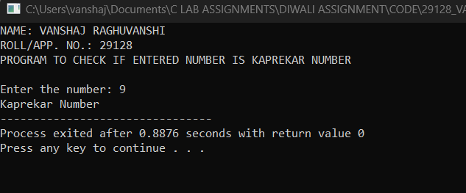***OUTPUT:-***

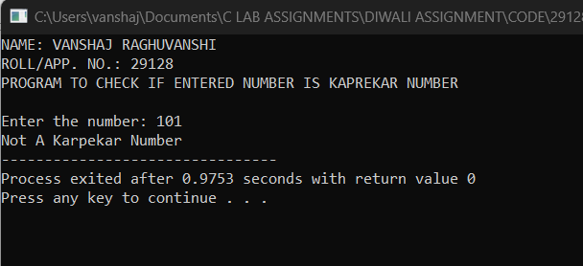

Que 7: Smith number

***CODING:-***

#include<stdio.h>

#include<math.h>

int main()

{

printf("NAME: VANSHAJ RAGHUVANSHI\nROLL/APP. NO.: 29128\n");

printf("PROGRAM TO CHECK IF ENTERED NUMBER IS SMITH NUMBER\n\n");

int n;

printf("Enter the number: ");

scanf("%d",&n);

int i,j,c,x,d,f,k;

x=n;

d=0,f=0;

c=0;

while(x>0)

{

d+=(x%10);

x/=10;

}

x=n;

while(x>1)

{

for(i=2;i<=x;i++)

{

if(x%i==0)

{

break;

}

}

k=i;

for(j=1;j<=i;j++)

{

if(i%j==0)

{

c+=1;

}

}

if(c>=2)

{

while(i>0)

{

if((i%10)!=0)

{

f+=(i%10);

i/=10;

}

else

{

break;

}

}

}

x=x/k;

}

if(d==f)

{

printf("%d is a Smith number",n);

}

else

{

printf("%d is not a Smith number",n);

}

return 0;

}

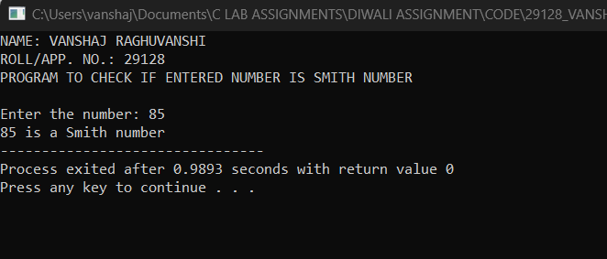***OUTPUT:-***

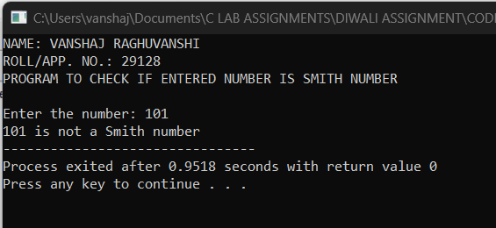

**Q8: Electricity bill**

***CODING:-***

#include<stdio.h>

int main()

{

printf("NAME: VANSHAJ RAGHUVANSHI\nROLL/APP. NO.: 29128\n");

printf("ELECTRICITY BILL\n\n");

int uid;

const float f=50;

float unit;

char name[50];

printf("Enter the user id of user:\n");

scanf("%d",&uid);

printf("Enter the name of user:\n");

scanf("%s",&name);

printf("Enter the number of units consumed by user:\n");

scanf("%f",&unit);

float charge;

if(unit>0&&unit<=100)

{

charge=unit*1;

if(charge<50)

{

charge=f;

}

}

else if(unit>100&&unit<=300)

{

charge=unit*2;

}

else

{

charge=unit*3;

}

if(charge>1000)

{

charge=charge+(0.15*charge);

}

printf("Charge deatils\n%d %s %.2f",uid,name,charge);

}

***OUTPUT:-***

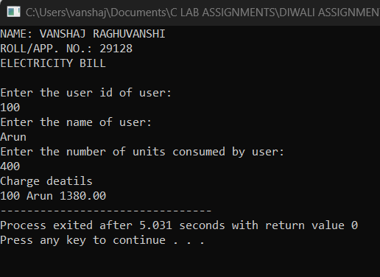

**Q9: Switch Operations**

***CODING:-***

#include<stdio.h>

int main()

{

printf("NAME: VANSHAJ RAGHUVANSHI\nROLL/APP. NO.: 29128\n");

printf("MENU DRIVEN CALCULATOR\n\n");

int n,x,y;

printf("Enter the first value:\n");

scanf("%d",&x);

printf("Enter the second value:\n");

scanf("%d",&y);

printf("Enter choice from the menu:-\n1.Addition\n2.Subtraction\n3.Multiplication\n4.Division\n");

scanf("%d",&n);

switch(n)

{

case 1:

printf("The value after Addition is %d",x+y);

break;

case 2:

printf("The value after Subtraction is %d",x-y);

break;

case 3:

printf("The value after Multiplication is %d",x*y);

break;

case 4:

printf("The value after Division(Quotient) is %d",x/y);

break;

default:

printf("WELCOME TO CALCULATOR");

}

return 0;

}

***OUTPUT:-***

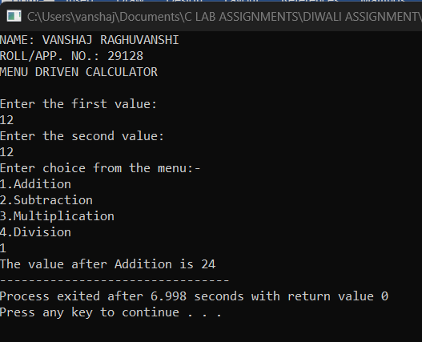

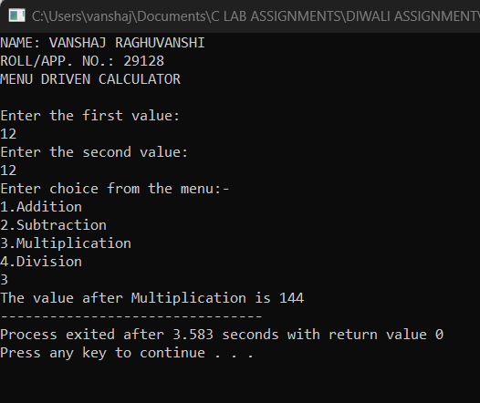

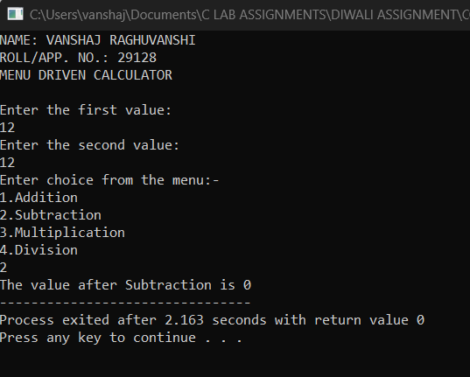



**Q10: Display grade**

***CODING:-***

#include<stdio.h>

int main()

{

printf("NAME: VANSHAJ RAGHUVANSHI\nROLL/APP. NO.: 29128\n");

printf("PROGRAM TO DISPLAY GRADE\n\n");

int r,m;

char name[50];

printf("Enter the roll number of student:\n");

scanf("%d",&r);

printf("Enter the name of the student:\n");

scanf("%s",&name);

printf("Enter the total marks of the student:\n");

scanf("%d",&m);

char grade;

if(m>=90&&m<=100)

{

grade='A';

}

else if(m>=80&&m<90)

{

grade='B';

}

else if(m>=70&&m<80)

{

grade='C';

}

else if(m>=60&&m<70)

{

grade='D';

}

else if(m>=40&&m<60)

{

grade='E';

}

else

{

grade='F';

}

if(grade!='F')

{

printf("Grade details\n%d %s %d %c",r,name,m,grade);

}

else

{

printf("Grade details\n%d %s %d Fail",r,name,m);

}

return 0;

}

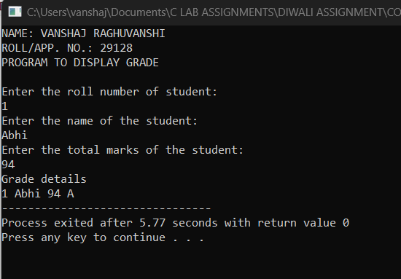***OUTPUT:-***

